KCH2 -

Functionality
A profit center group is a hierarchical structure of profit centers.
You can use profit center groups to group profit centers together according to company-specific criteria. Profit center groups are used for reporting, allocations or in various planning functions, where it does not make sense to enter or display data at the lowest level (with a high level of detail).

Scenario
This transaction is used to change a profit center group.

Requirements
None.

Menu Path | SAP menu → Accounting → Controlling → Profit Center Accounting → Master Data → Profit Center Group → KCH2 - Change
Transaction Code | KCH2

1. Double Click on KCH2 – Change.

Change Profit center group: Initial Screen

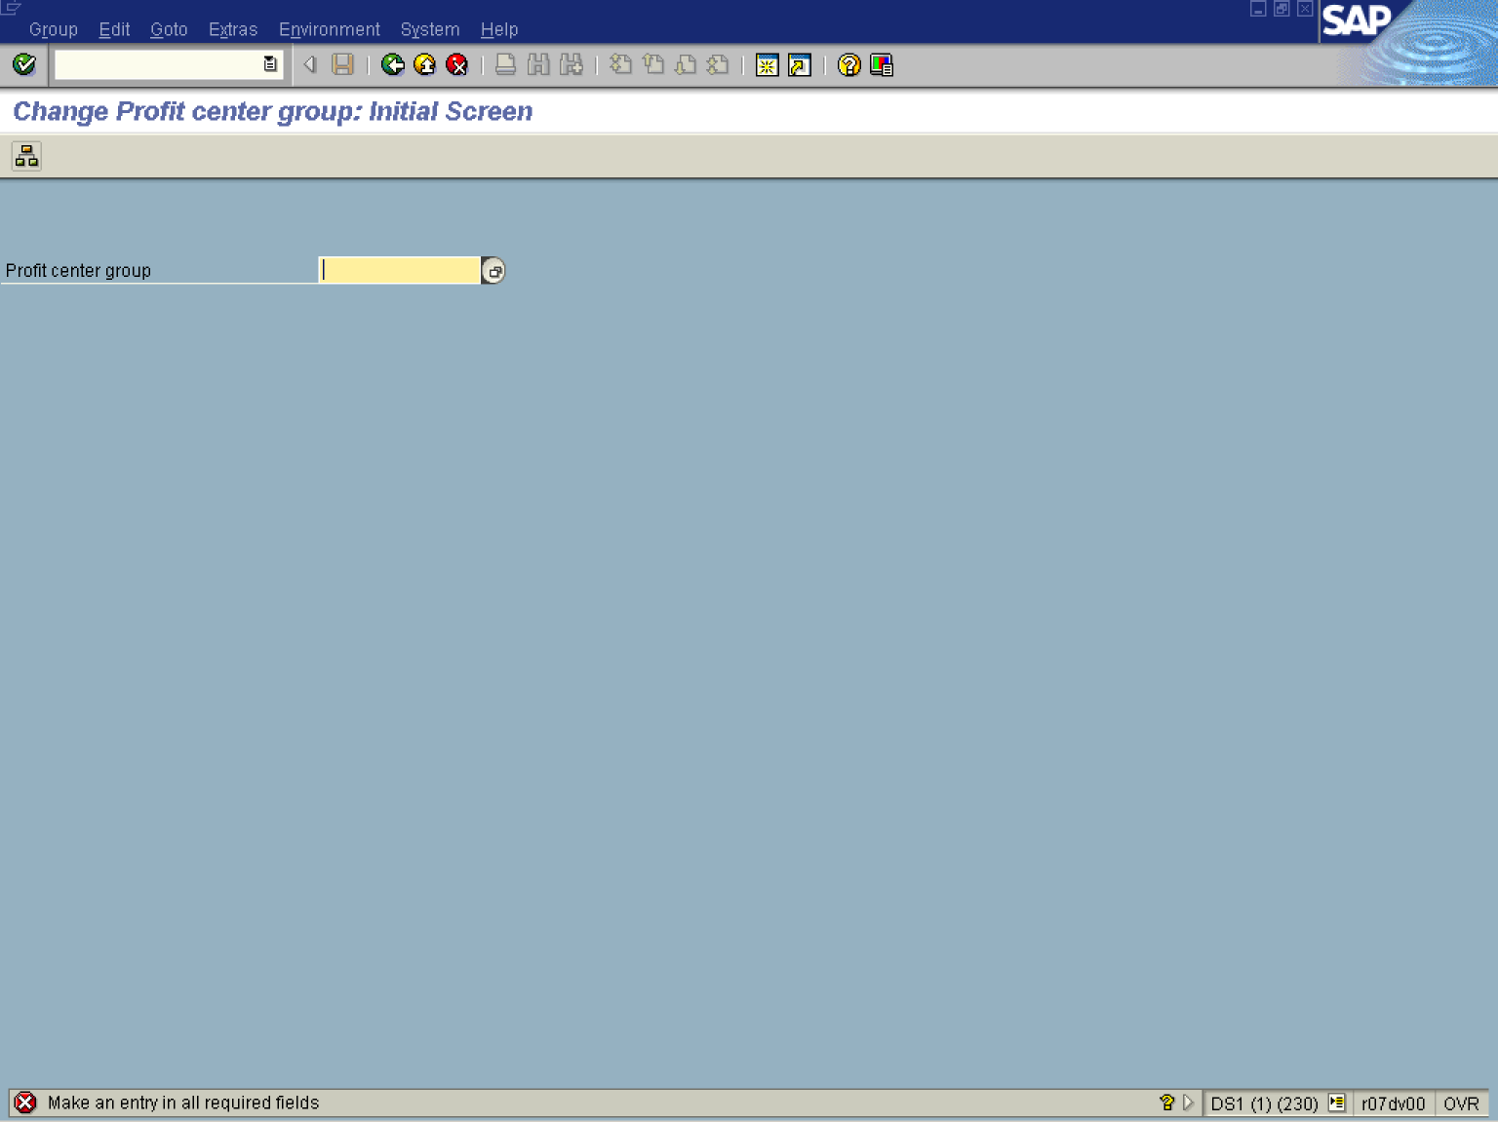

2. Press [F4] or Click the Search button in the Profit center group field .

Profit center group

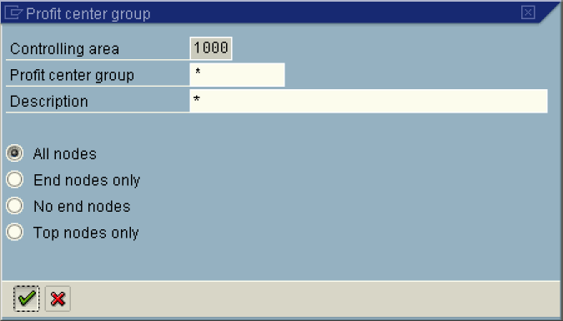

3. Click the Enter button.

Selection Profit center group (1) 34 Entries found

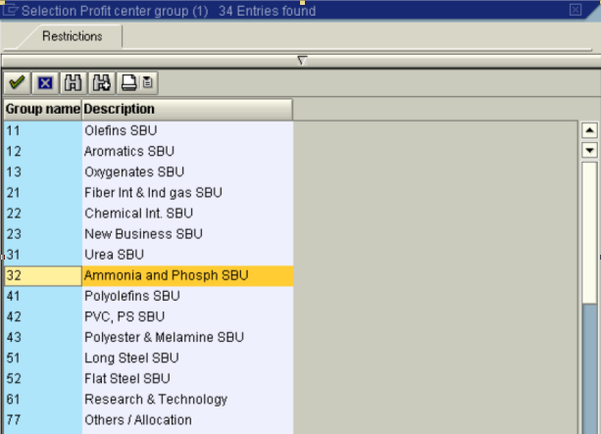

4. Select 32 - Ammonia and Phosph SBU in list box.

Change Profit center group: Initial Screen

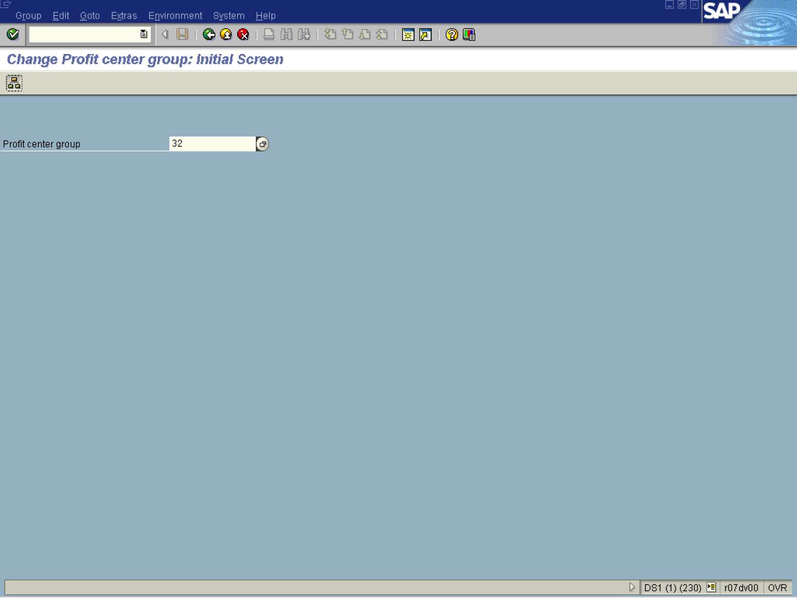

5. Click Display menu of an activity group Shift+F5 Button .

Change Profit center group: Structure

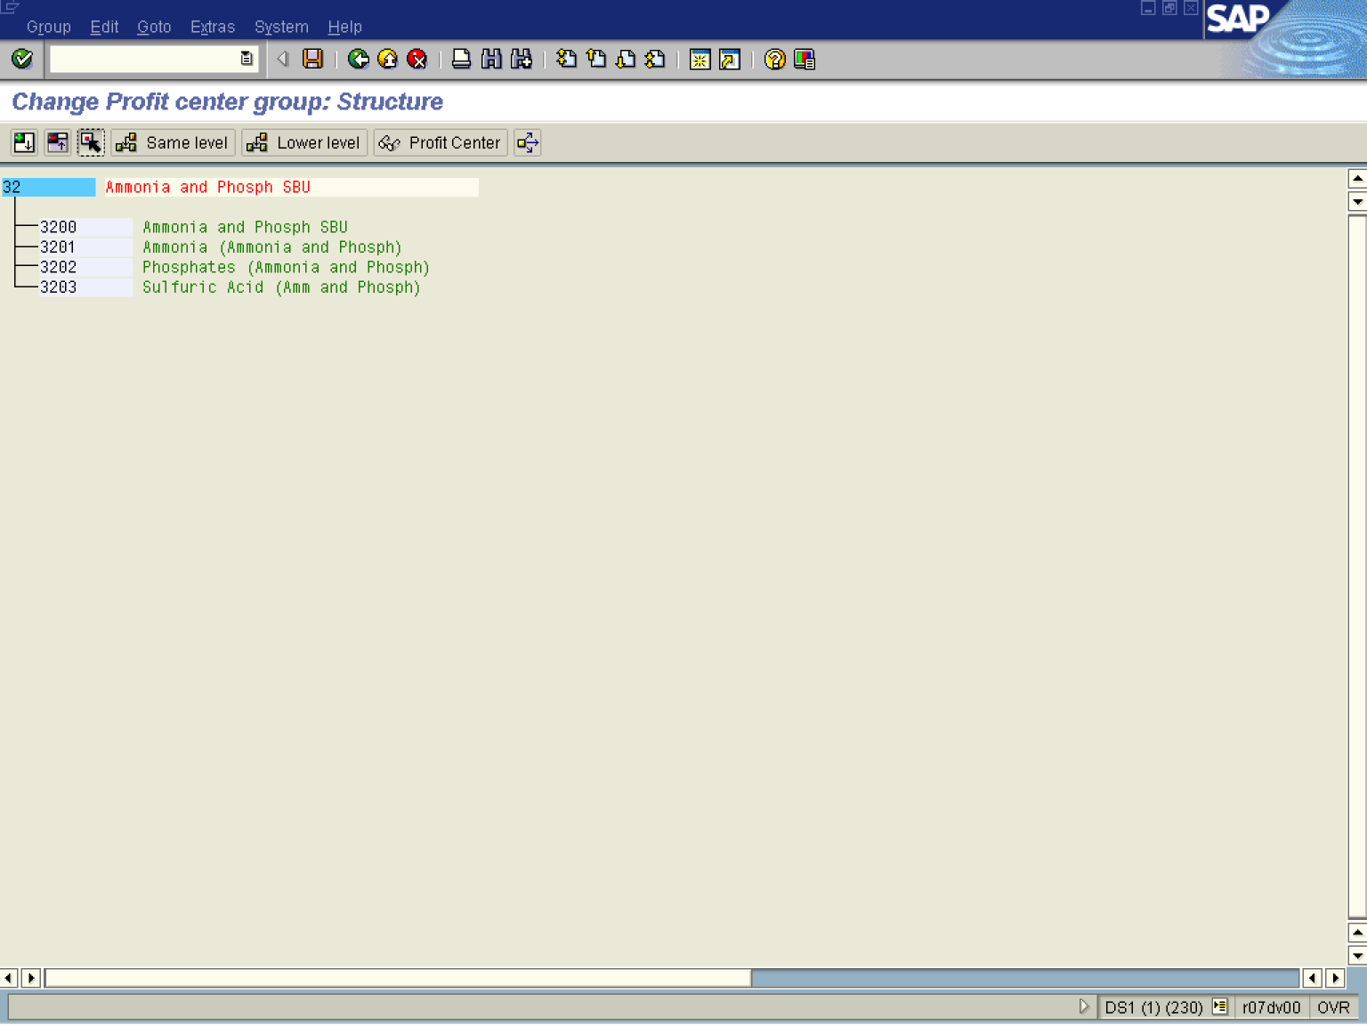

6. Update the following fields:

Field Name | Field Description | Values
Group Name | Description of the profit center group. | Example: 32 Ammonia and Phosphor SBU

7. Click on the button to add groups at the same level as a pre-selected group.
8. Click on the button to add groups at a lower level as a pre-selected group.
9. Click the Save button.

Change Profit center group: Structure

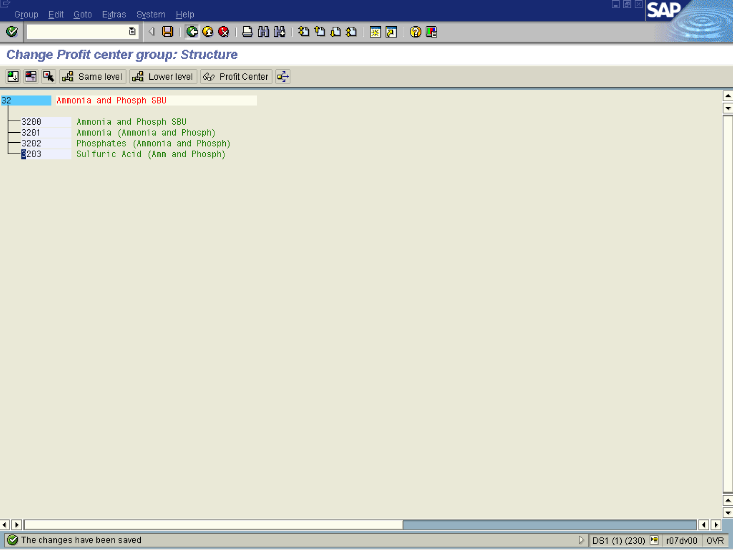

10. The message bar displays “The changes have been saved”

